1. Select the AC Power from Power Sources through component list. Set the RMS value 230V and frequency of 50Hz. Connect resistor of value 100K across this power source. Measure this set value on CRO and observe peak value. Note down the peak value. What is peak to peak voltage? Now measure this voltage of AC Power source with multimeter as an AC Voltmeter. What is the reading in multimeter? Write the difference between the reading of CRO and reading from multimeter.

Peak Value = 322.633 V.

Peak To Peak Voltage = 647.243 V .

Reading Of Multimeter = 229.982 V.

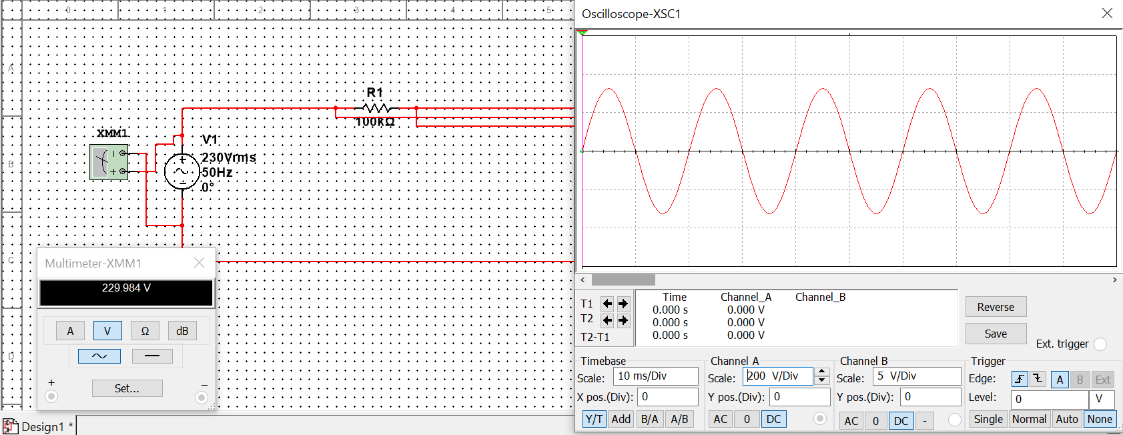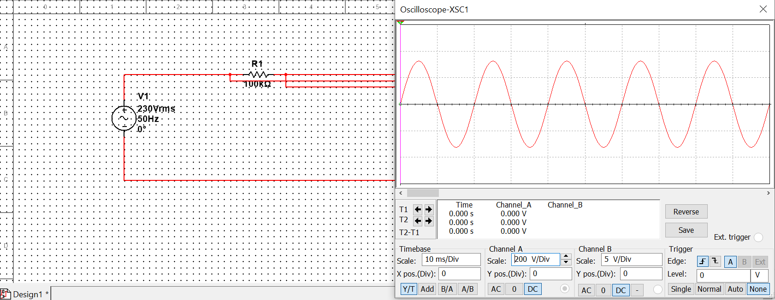Difference – 92.651 V

1. Select the AC Voltage from Signal Voltage Source through component list. Set the peak voltage as 5V and frequency of 5KHz. Keep offset voltage 0V.Connect resistor of value 1K across this AC signal. Measure this set value on CRO and observe peak value. Note down the peak value. What is peak to peak voltage? Now measure this voltage of AC Signal source with multimeter as an AC Voltmeter. What is the reading in multimeter? Write the difference between the reading of CRO and reading from multimeter.

Peak Voltage- 5 V

Reading Of Multimeter- 3.535 V

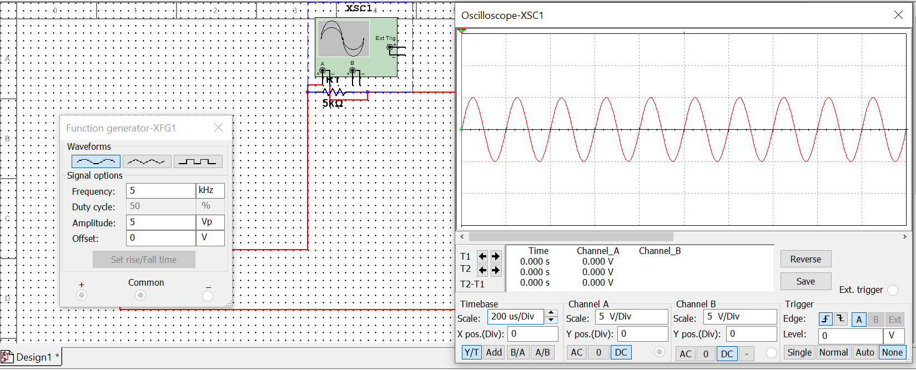Difference – 1.465 V

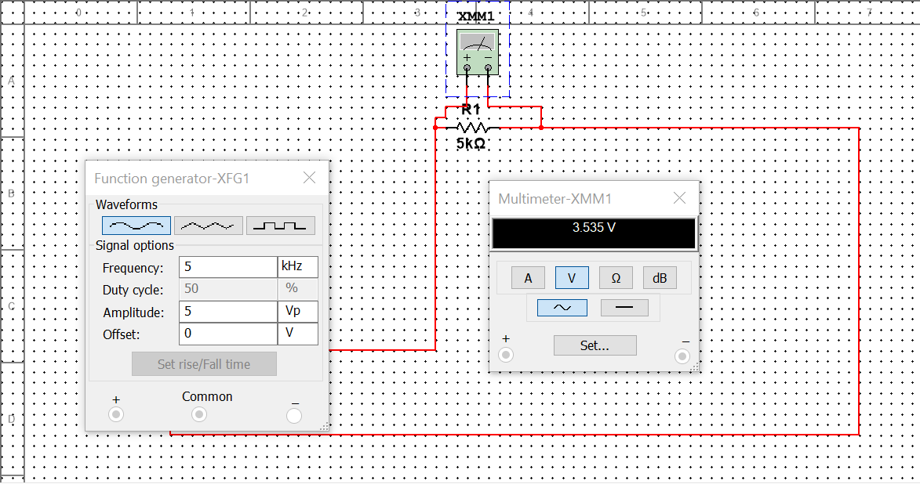

1. 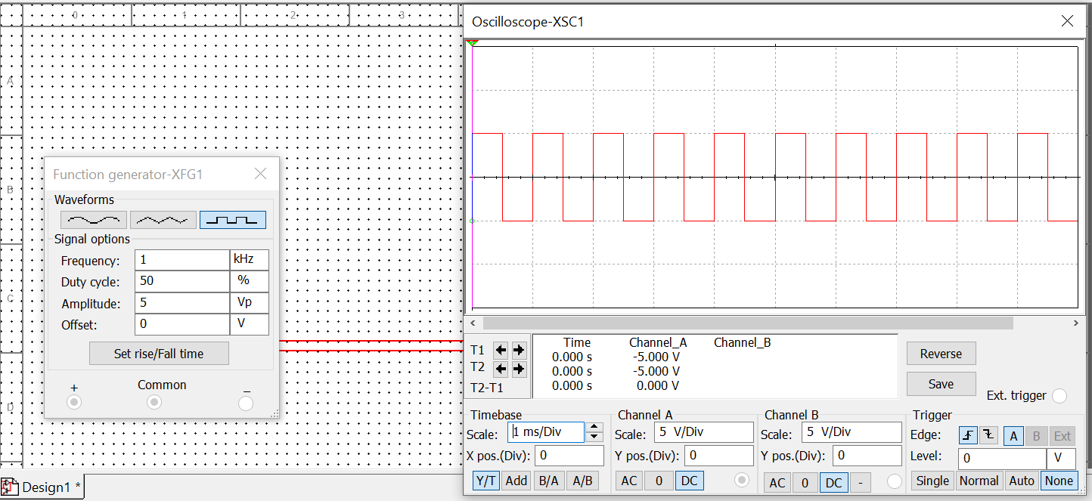Using Function Generator generate square wave of frequency 1KHz and peak value Vpeak =5V.Keep DC offset zero volt. Keep duty cycle 50% initially and observe the waveform on CRO. Change the duty cycle to (1)20% (2)40% (3)60% (4) 70%. Observe the waveforms on CRO for all different values of duty cycle.

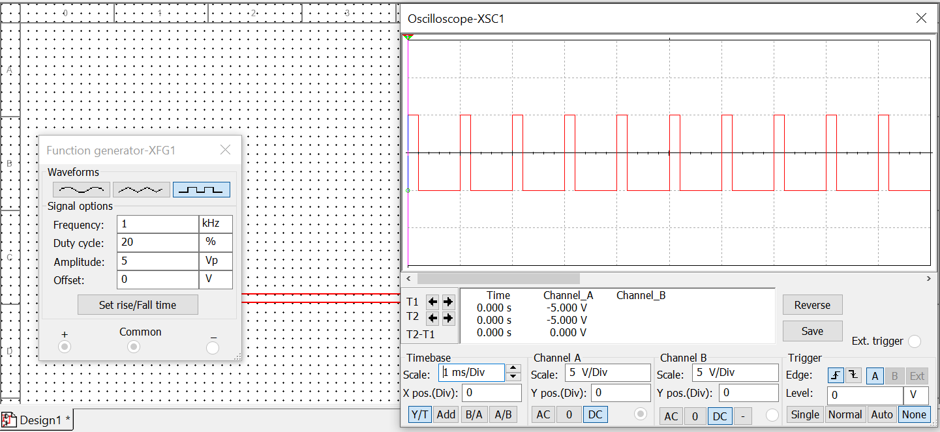I)

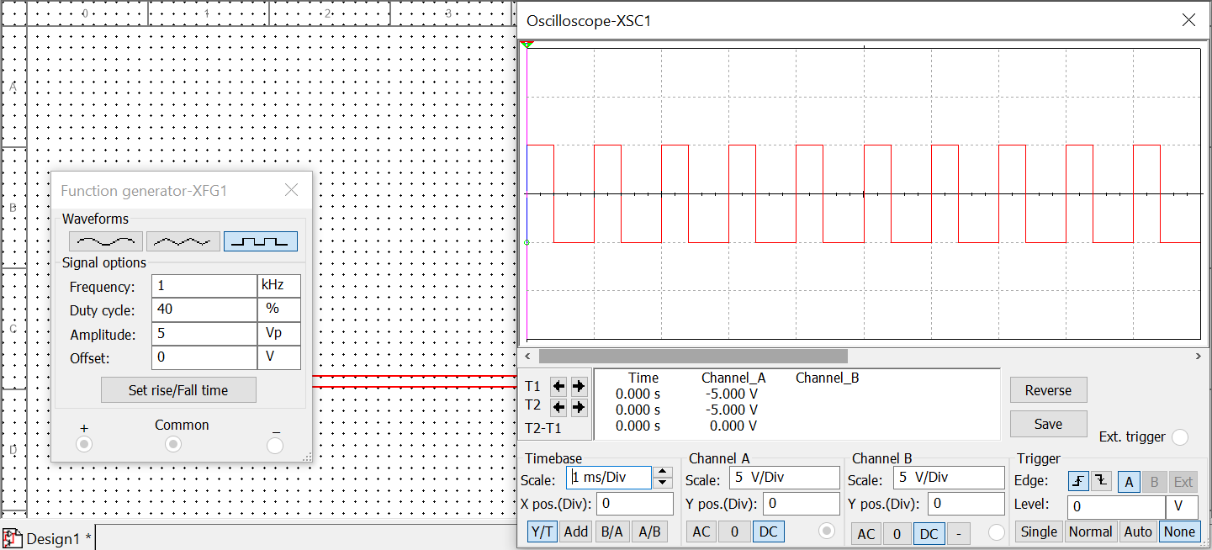II)

III) 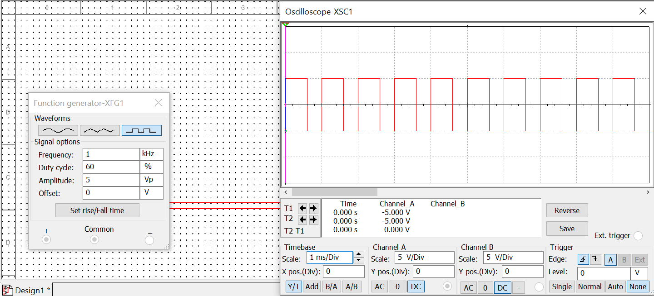

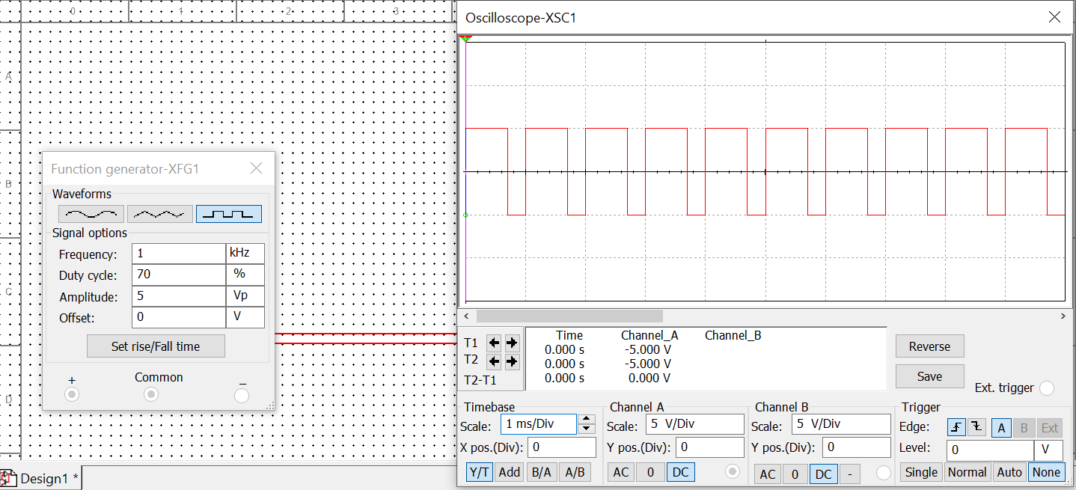IV)

1. Select the AC Power from Power Sources through component list. Set the RMS value 230V and frequency of 50Hz. Now choose transformer having one primary winding and one secondary winding(1P1S) from component list. Set the transformer as a step down transformer with turn ratio 10:1.Connect resistor of value 10K across the secondary winding. Do the following tasks. (1) Measure the voltage value across this resistor using CRO and observe peak value. Note down the peak value. What is peak to peak voltage? (2) Measure the voltage of primary winding on channel A and secondary voltage on channel B so you can observe both channel simultaneously. (3)Change the turn ratio to 20:1 and repeat tasks 1 and 2
2. Peak Voltage- 32.036 V

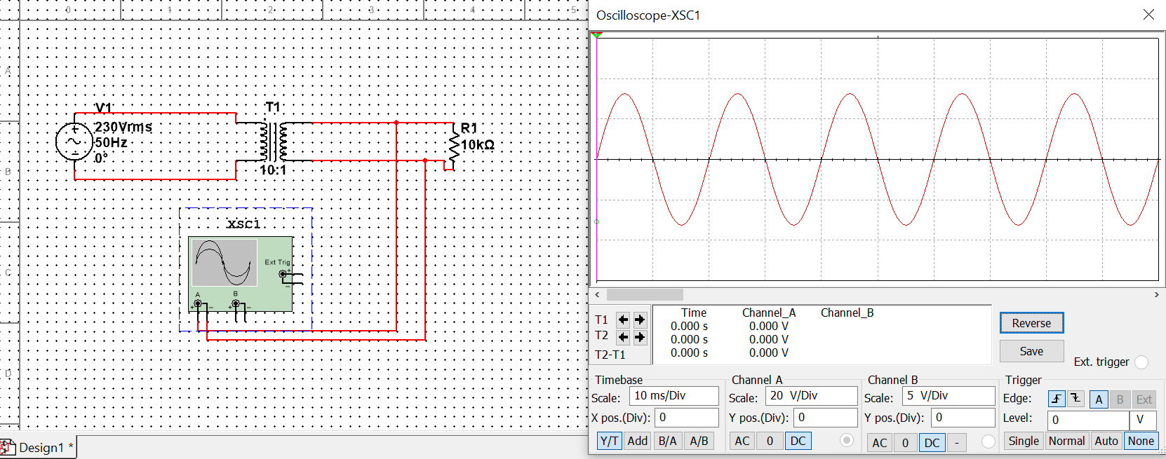

1. 